In the "SPR Data Files" folder, there is a Google spreadsheet "210402_Spyros_Cycle_Legend" with two tabs:
- Tab "201008_851bew075" corresponds to the experiment with CTH.
- Tab "201203_851bew104" corresponds to the experiment with Human Histones.
Looking at the CTH tab, columns A-E describe the immobilization phase.
- You used two channels: FC3 and FC4.
- FC3 is the channel in which you constructed your control surface, which is absent of the CTH-specific aptamer. Therefore, it only sees injection 4 with the MCH.
- FC4 is the sensing surface, which has three consecutive injections with the aptamer, followed by the MCH exposure.
- This data is recorded vs. time in "Immobilization_CTH.txt". I note that I have created a .xls file with everything combined. I also note that in the .txt file FC1 and FC2 are used rather than FC3 and FC4. Could you please check this?
Columns G-K contain a table with the sequence of injections (i.e., "cycles") in the SPR.
- Cycles 1-3 contained an injection of HBS-EP+, which is the solvent in which the various concentrations of BSA and CTH are dissolved throughout this experiment. It also serves as the running buffer.
- Cycles 4-12 represent a dilution series of CTH. To illustrate how this works, I have plotted Cycle 10. There are three traces vs. time: (1) FC3 (control), (2) FC4 (sensor) and (3) FC4-FC3 (differential response). We typically only focus on the association and dissociation phases. The regeneration step aims to remove the binded CTH and provide a "fresh" surface. The "response" for a surface at a particular concentration is given by the RU at the end of the association phase minus the RU at the initial injection. For this reason, it is typical to correct the data by setting the RU at injection equal to zero.
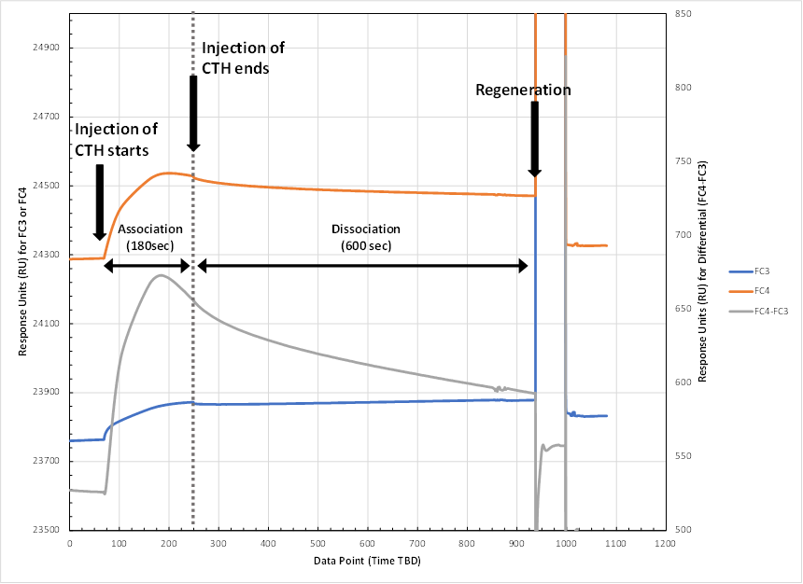

- Cycles 13-21 represent a dilution series with BSA. BSA was used as a negative control.
- Cycles 22-25 were follow-up measurements conducted with CTH and BSA to check the repeatability of the results.
More details on the above can be found in the PPT that Duke provided us, entitled, "Calf_Thyums_Histone_SPR_Results".

The same type of analysis would be used for the other experiments.

